[**https://lms.beetroot.academy:3005/pub/e2bb6c3b-909a-492a-88b9-b680445731cf.html**](https://lms.beetroot.academy:3005/pub/e2bb6c3b-909a-492a-88b9-b680445731cf.html)

**Перший рівень**

Перше завдання

Issue Title: The contact form accepts a non-existent email

Issue Type: Bug

Priority: High

Author: Oleksandra Herasymova

Severity: High

Description

Steps:

1. Open the page https://www.headhunterhairstyling.com/
2. Find contacts in the upper curtain
3. Fill out the form, enter an unreal email, at the end it must be @gmail.com
4. Click "Send"

Expected result: The form does not accept the request

Actual result: The form accepted the request

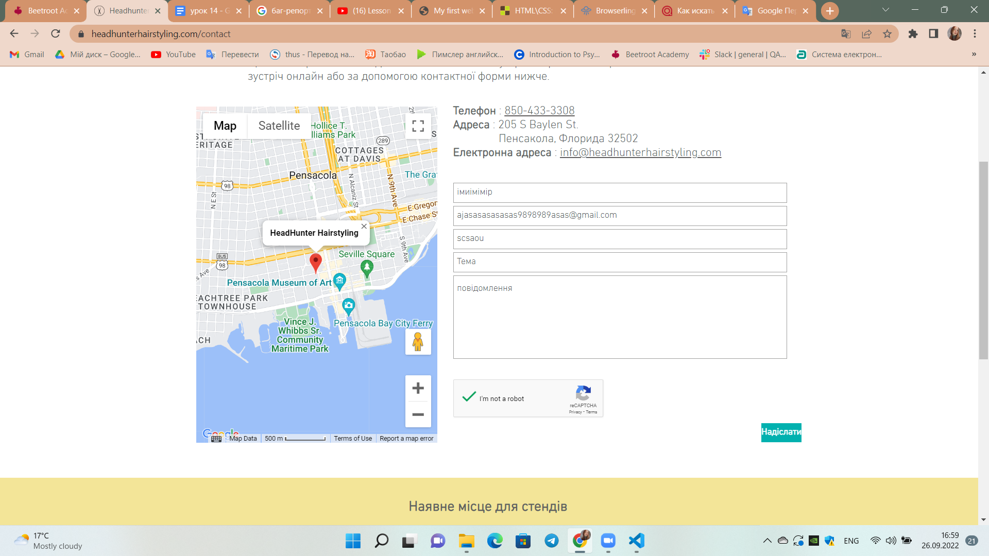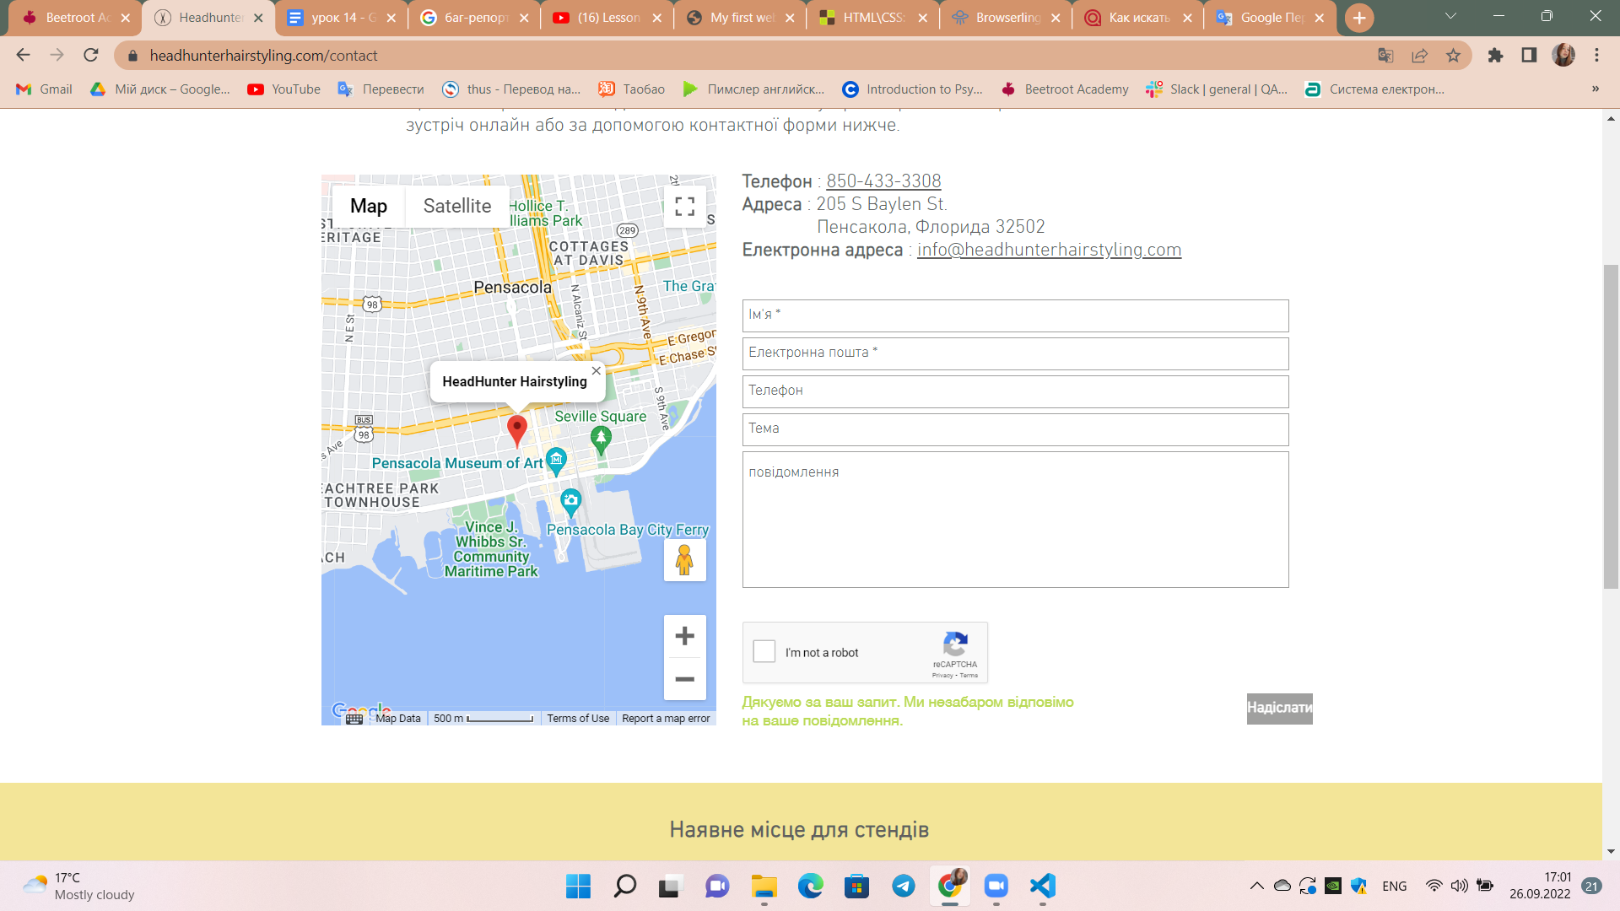

Issue Title: The contact form accepts a non-existent number

Issue Type: Bug

Priority: High

Author: Oleksandra Herasymova

Severity: High

Description

Steps:

1. Open the page <https://www.headhunterhairstyling.com/>
2. Find contacts in the upper curtain
3. Fill out the form, enter the number in letters
4. Click "Send"

Expected result: The form does not accept the request

Actual result: The form accepted the request



Issue Title: Clicking on the logo does not open the main page

Issue Type: Bug

Priority: Low

Author: Oleksandra Herasymova

Severity: High

Description

Steps:

1. Open the page <https://www.headhunterhairstyling.com/>
2. Go to any position in the header of the site
3. Click on the logo

Expected result: Open main page

Actual result: No reaction

Третє завдання

Я перевіряла HTML-документ в Google, Firefox та Microsoft Edge. Ніяких тотальніх змін не побачила.